**Week 6 Diary**

**📝 Plan:**

1. Maps creation.  ✅

2. Go into other maps. ✅

3. Shooting and bullets collision detect ✅

4. Design of enemies ✅

5. Welcome page, achievements, etc. ⚠

**🚫 Problem:**

①Initially, I put all fixed items (ladder, coins and respawn circle) into the const map array. But the character is easily stuck during these edges (caused by collision detection). Then I changed my mind, I simply regarded the map as the only background, all others are in a floating layer above it, they are rendered dynamically each frame.

②My character went across the walls one time during developing!!! That’s unbelievable! It seemed like I created a cheater that allowed the player flew above the maze! I spent 2 days finding out the problem: I accidentally deleted the initializer of variables “*player.x* and *player.y*” which determine the position. Then the random value of position failed collision detection function!

💡 **Ideas:**

Collect coins in maps and purchase spells (increase damage, speed, recover HP) and advanced weapons.

**🎁 Outcome:**

1. More maps, ladders, and chests (Fig.1)

Sometimes you may luckily enter a chest room, you may find useful spells or weapons here (add in future).

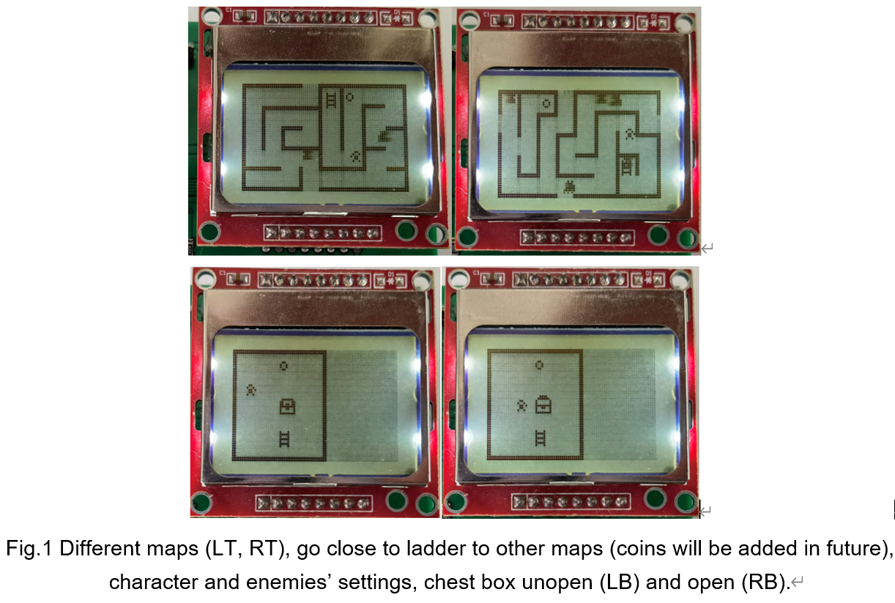

2. Shooting and collision detect

By pushing button C, character can shoot bullets. There will be varies of bullets (style and damage), and each kind of enemies has its HP. Bullets disappear when hitting any entities. Photos and codes will be given in final version (too many).

3. Design of enemies (Fig.2)

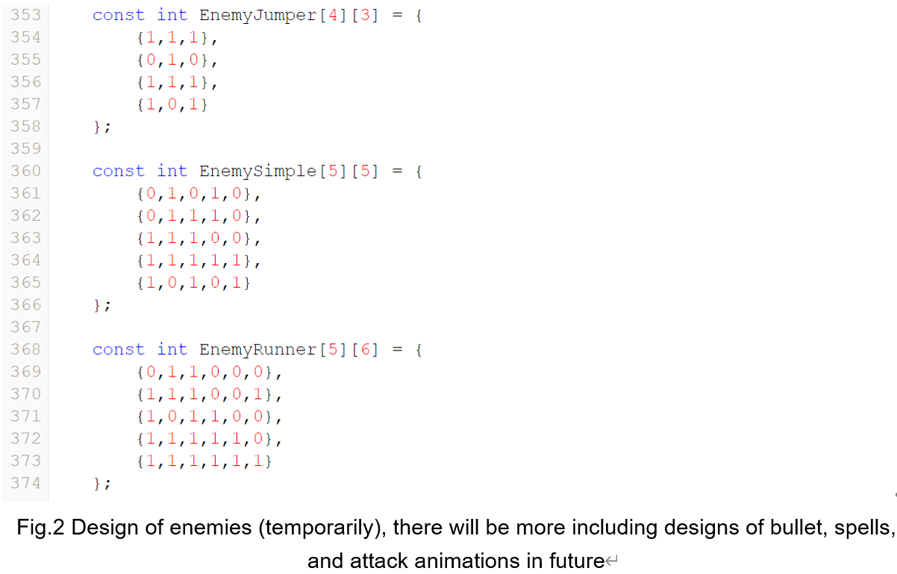

4. Welcome page, menu, and achievements (Fig.3)

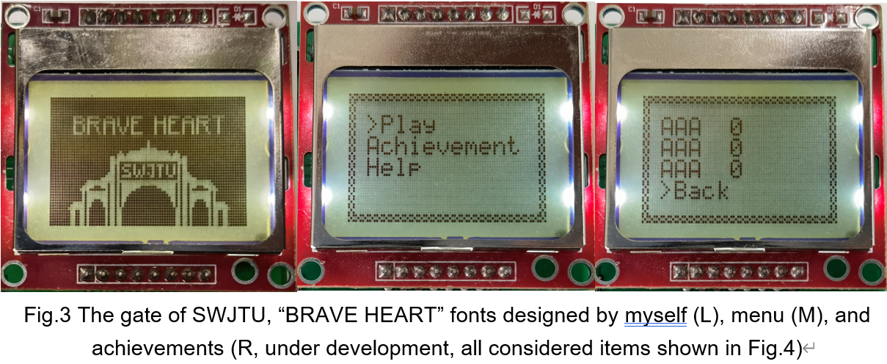

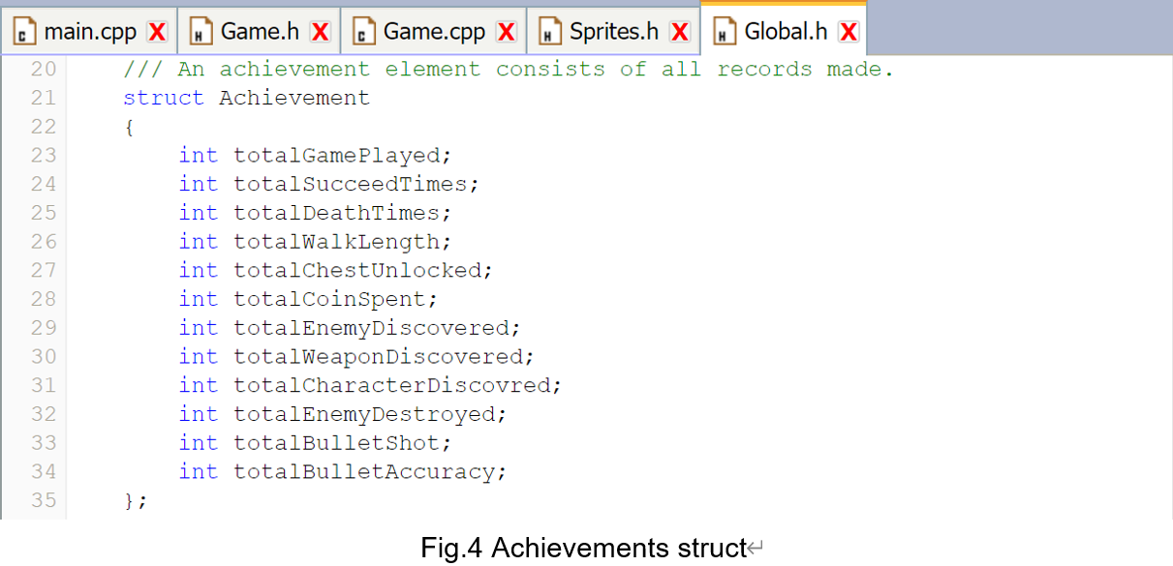

5. Others.

‖ Seven-segments Display used to show the lives left (Fig.5)

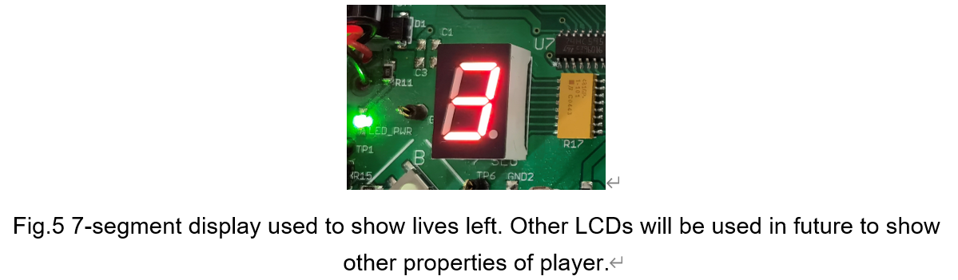

‖ Bugs including go across walls are fixed.